Web Programming

Report- **Highway Help!**

CLASS - **D10**

GROUP MEMBERS-

|  |  |
| --- | --- |
| **ROLL NO** | **NAME** |
| 02 | BHAVIKA ADNANI |
| 12 | AARTI BHAGTANI |
| 19 | SIMRAN BHOJWANI |
| 26 | HEENA DAWANI |

**Abstract :-**

Highway Help website aims to provide help to people who are stuck at highway.

Some of the various services required at Highway include :

* First Aid
* Services
* Mechanics
* Emergency Care Services/Hospitals
* Other Transport Facilities
* Restaurants
* Cottages
* Emergency Contacts

**First Aid :**

This includes first and foremost steps which should be taken by commuter in case of accidents/sudden health issues that can be carried out by a lay person until professional medical assistance arrives.

**Services :**

The website track the user and displays the above nearby services within a range of 1000m.

*For eg***:** If the user chooses Mechanic services based upon his current location all the mechanics within the radius of 1000m are displayed along with some details of the garage name like name, phone number, website and rating( by google )

To reach there or to decide the next step or call them at your location with required tools to repair your vehicle.

**Emergency Contacts** :

This includes the contact numbers(police, ambulance, fire, etc) and some of the particular Highway helpline numbers which are required in case of urgency.

**Functional requirement :** The ability to assist the commuters/tourists at highway at one website with simple and easy to use user-interface.

**Non-functional requirements :** All the data provided for services is using Google maps API which may sometime have limited accuracy.

**Introduction to the system :-**

Our website based on user-location provide information of nearby services. Also provide basic first-aid information and emergency contacts list.

At present Google maps provide in general information whereas Highway Help is more particular to highways.

**Goals :-**

A web**-**application to help people on highway by providing them all the information that may be required in emergency at just one site - Highway Help!

**Objective:-**

Highway Help is one stop destination for all the info regarding necessary services on highway...  
Highway Help provides details of essential services which are a must on any highway

* Location of available mechanics nearby.
* Details of Hospitals and
* medical services for accidents or any case of emergency.
* Restaurants and cottages for the travellers to take rest and get charged up to continue their journey.
* Other transport facilities available on their route.

**Functional requirements :-**

* Whenever a user enters the website, it tracks the user only after user allows the website to know location.
* On choosing any service(Mechanic, Hospital, Other Transport, Restaurants, Cottages), it again asks user to know location and displays the services in radius of 1000m and provides the details such as rating, contact, open now, website, address.
* In Emergency contacts page it displays the emergency contacts fire, ambulance, police, women, child safety,etc. Along with the highway specific helpline numbers which will be dropped down on clicking a particular highway name.
* In First-aid page it displays the foremost actions which should be taken at time of emergencies that can be performed by lay-man with the easily available equipments with him.

**Non-Functional requirements :-**

* **Accessibility :** It is Accessible by everyone.
* **Reliability :** All the data provided for services is using Google maps API which may sometime have limited accuracy.
* **Portability :** The website can be viewed from any device.
* **Response time :** Response time depends upon the loading of Google maps.
* **Usability :** It has simple and easy to use user-interface.

**Technology Stack :-**

Highway Help website uses various technologies for designing the front-end and back-end.

**Front-end :**

HTML for the basic development of the web-pages.

Cascading Style Sheetsfordesigning of the website.

Jquery and Javascript is used to make web pages more attractive and dynamic.

**Back-end :**

Extensive use ofgoogle APIwhich make the website dynamic as the main purpose of the website is to provide the various services.

The google api used in the JavaScriptpart are used for locating the user’s location.

The api’s place searche***s*** are used for finding the places searched.

The place detailsprovide the description of the places which fulfill the user’s requirement.

The website usesphp to store and retrieve data from database in reviews of the website.

**Screen designs :-**

**Index-**

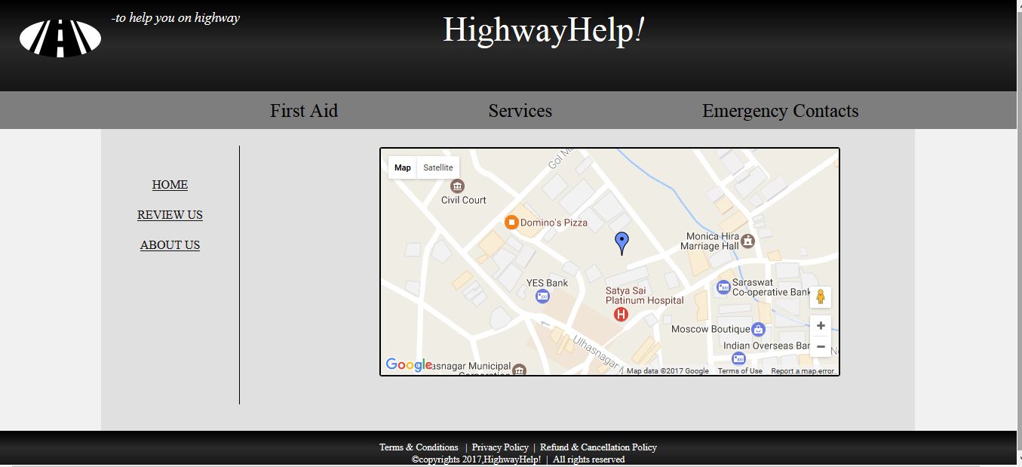

R **First aid-**

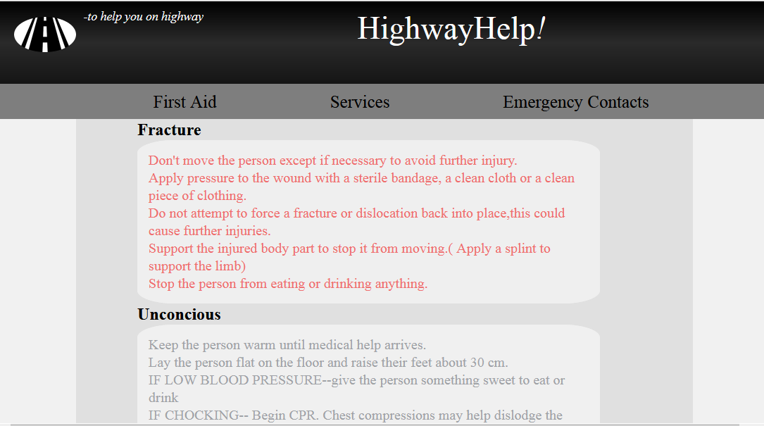

**Services-**

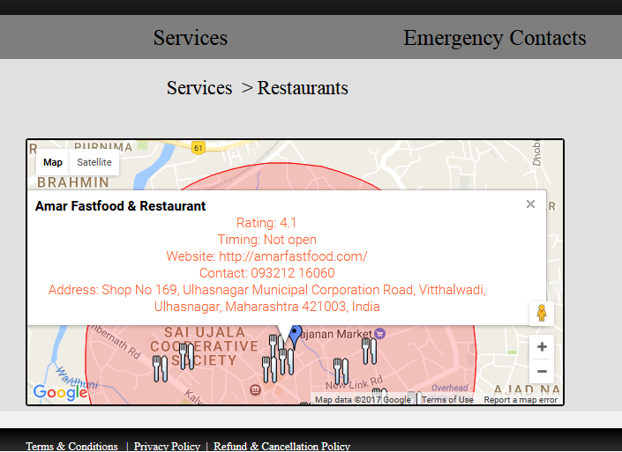

**Emergency contacts-**

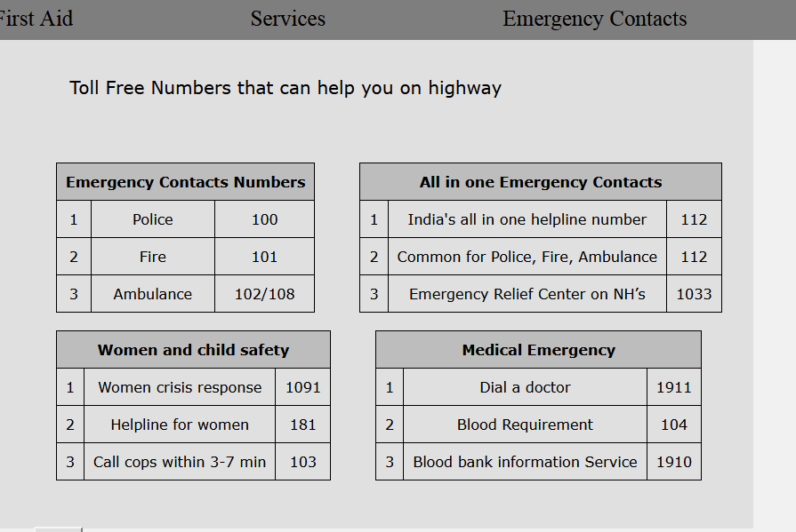



**About Us-**

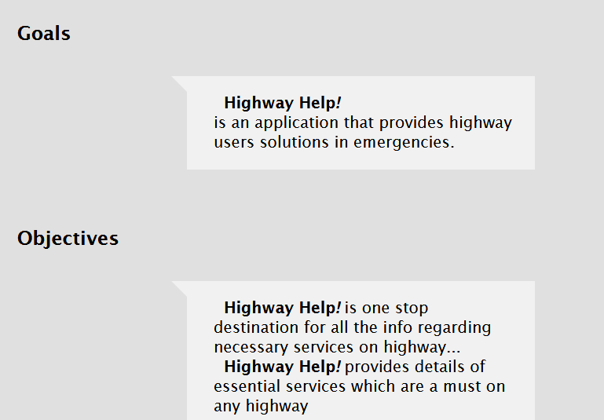

**Responsiveness-**

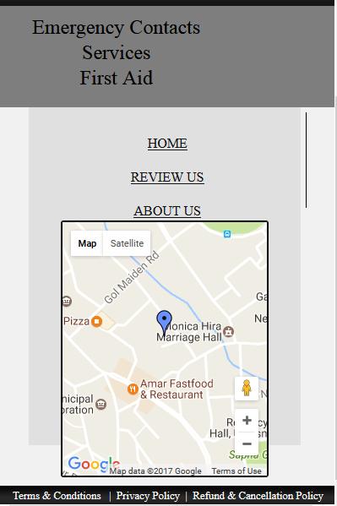

**Review Us-**

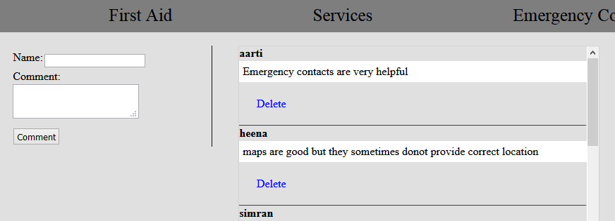

**Zoom in satellite mode**

(draw circle on map for the selected radius)

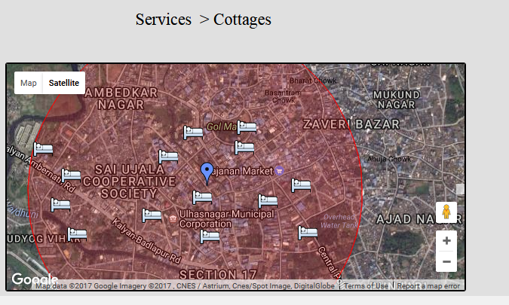

**Zoom out**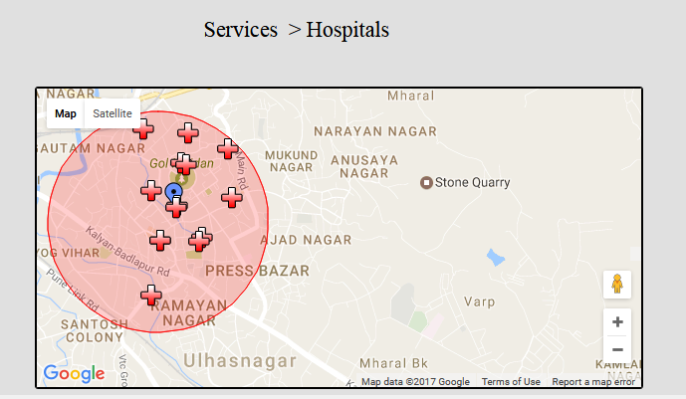

**Implementation strategy :-**

**Base**

* Header has logo link ,tagline and name.(**Html5 / css3**)
* Body has left and top navigation(**jquery**) along with dynamic section.
* Footer has policies and copyrights.**(Html5 / css3)**

**Home**

* Marks current location of the user.(**google api createMarker function**)

**First aid**

* Highlights specific first aid treatments in various cases(**jquery**)

Services(all pages)

* Gives the details nearby services available to user (**google api getDetails function**)

**Emergency contacts**

* Provide static necessary contacts like Fire, ambulance, safety along with highway specific helpline numbers**(CSS, jquery)**

**Review Us**

* People can comment about the service they have used.(**php database**)

**Conclusion :-**

**Achievements** : Html5, css3, javascript,jquery, php, database connectivity, Google apis.

**Future scope :**

* More Services like ATM, restrooms, Petrol pumps, online toll payment, filtering of the current services based on open now, ratings.
* An *mobile-application* for the same as travellers uses smartphones which will be more handy, convenient, quick than a website.
* An application can also provide ease of sending notifications for the petrol pumps, Tolls and/or other services ahead on highway.
* To display the services based on the location entered by user explicitly instead of current location of user.
* To display the services based on the distance entered by user explicitly instead of in a radius of 1000 m.